|  |
| --- |
| ACTS |
| Advanced Low-level Controller – ALC 3.0 |
| User Manual |
|  |
| **[键入作者姓名]** |
| **2019/9/26** |

|  |
| --- |
| ACTS Technologies Inc. |

Contents

1 Overview 3

2 Copyright Page 3

3 Main Functions 4

4 Main Window 4

4.1 File Menu 4

4.2 Define Menu 6

4.3 Display Menu 11

4.4 Toolbox Menu 13

4.5 Help Menu 15

4.6 Main Function 16

5. How to define a PID controller 19

5.1 Define a PID Controller Dynamic Link Library 19

5.2 Define a PID Modifier 19

5.3 Define a PID Controller Signal 19

# 1 Overview

The purpose of this document is to familiarize the user with the operation of the ACTS Advanced Low-level Controller – ALC 3.0.

**1 ACTS Software Icon**

Figure 1 shows the ACTS software package installed in the IPC 3.0. By double clicking the icon, ALC 3.0 will be launched.

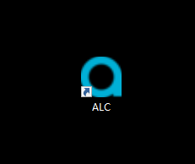

*Figure 1 – ALC software icon*

# 2 Copyright Page

Figure 2 shows the ACTS software copyright page.



*Figure 2 – ALC software copyright page*

# 3 Main Functions

ALC 3.0 is one of the ACTS software series. Its main function is real-time control, and completing the HSS hybrid simulation experiment by standard network interface with the ACTS HSS software. ALC provides users with a custom controller interface function.

# 4 Main Window

Figure 3 shows the Main window. It includes three bars and one sub-window：Menu Bar, Tool Bar, Status Bar and Control Window.

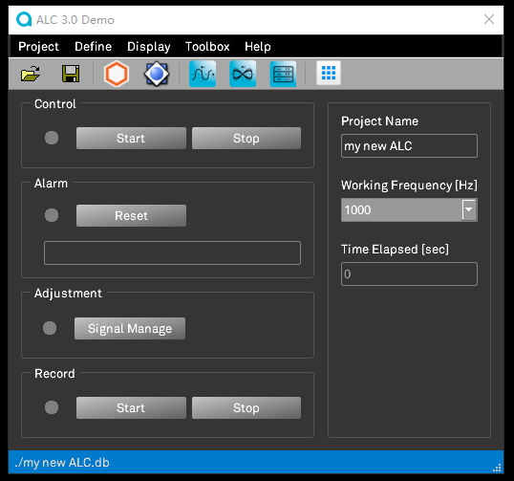

*Figure 3 – Main window*

## 4.1 File Menu

When the main window is first opened, ALC will create a default database (./my new ALC.db) for the user in the current directory. The database contains various real-time control signal definitions, and the user can modify, expand and save the database as your own project database.

4.1.1 New

By clicking “New”, ALC will start with a blank project.

4.1.2 Open

By clicking “Open”, open a project previously saved by the user.

4.1.3 Save

By clicking “Save”, ALC will save all settings to a pre-defined file. If no file has been pre-defined, ALC will consider “Save” as “Save as”. “Save”menu will be hidden when “Auto Save”menu is checked.

4.1.4 Save as

By clicking “Save as”, allow the user to choose the file location and name to store the current settings.

4.1.5 Auto Save

ALC will save all settings into the current project file automatically.

4.1.6 Preferences

By clicking “Preferences”, a window as shown in Figure 4 will be opened to allow the user to changed current font size and windows background color.

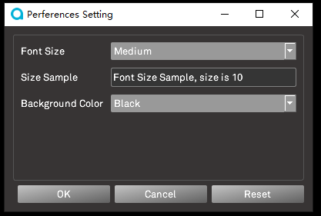

*Figure 4 – Preferences setting window*

4.1.6 Recent Projects

“Recent Projects” menu includes sub menu items which keep the recently opened project names; to click the sub item can open them directly.

4.1.7 Exit

By clicking “Exit”, ALC will be closed.

## 4.2 Define Menu

4.2.1 Input Channel

By clicking “Input Channel”, a window as shown in Figure 5 will be opened. All system pre-defined input signals which have the same quantity as the system input hardware channel will be listed. The user can click the “Enable” check boxes to enable them. Only enabled input signals can be used in ALC system. Double clicking “Input Signal Name” can edit the input signal name.

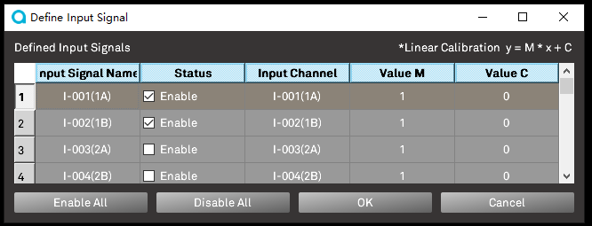

*Figure 5 – Define Input Signal window*

**4.2.2 Modifier**

By clicking “Modifier”, a window as shown in Figure 6 will be opened. This function defines the Signal Modifiers, which include Filer，Integration， Differential and User Define Signal Modifier types. These Signal Modifiers can be used to modify signals which can be selected in “Signal define” window when defining signals.

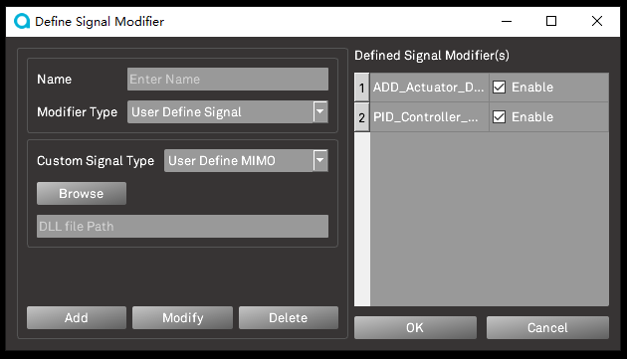.

*Figure 6 – Define Modifier window*

4.2.3 Signal

By clicking “Signal”, a window as shown in Figure 7 will be opened. This function defines the Signals, including the following：

Non-Sourced Signal：System generated, no other signals required as input. Including Const ，File， and Sine signal。

Sourced Signal：Relying on other signals as input signals, the signals generated by the system are reprocessed. Including Linear Conversion, Filter Processing, Integration, Differential, and User Define Signal.

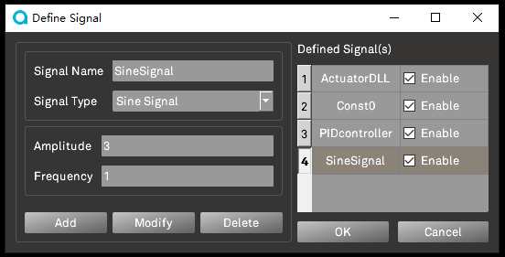

*Figure 7 – Define Signal window*

Before defining a User Define Signal, a template must be provided according to ACTS to create a dynamic link library (DLL). The template contains upper limits of input parameters, input signals and output signals. In addition, ALC has established two User Define Signal samples (PID controller and signal synthesizer) in the system for user reference. (For details, refer to Section 5, How to define a PID controller)

4.2.4 Output Channel

By clicking “Output Channel”, a window as shown in Figure 8 will be opened. This function assigns a defined signal to each output channel. The number of output channels is determined by the system hardware. By selecting “Signal Name” combo box, choose the output signal for this output channel. After enabling the “Enable” check box, the signal will be sent out.

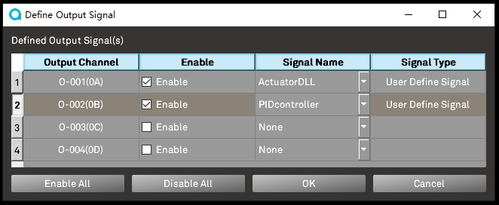

*Figure 8 – Define Output Channel window*

4.2.5 Define Limit Detector

By clicking “Define Limit Detector”, a window as shown in Figure 9 will be opened. The user can define the upper and lower limits for each previously defined signal, and select one of the “Warning”, “Pause ALC” and “Stop ALC” three actions when signal exceeds the limit during a test. After checked, the signal will be detected. Click “OK” to save the settings and effective immediately while the control thread is running; otherwise click “Cancel”.

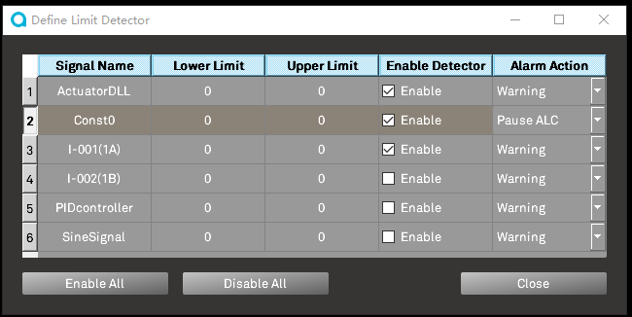

*Figure 9 – Define Limit Detector window*

4.2.6 Define Record Information

By clicking “Define Record Information”, a window as shown in Figure 10 will be opened. The user can select the previously defined signal for recording. All the available signals are listed in the table, the user just need check the “Enable Record” check box to select them for recording. The user will use “Browse” for the location to store the signal data, and use “Record Rate [Hz]” combo box to set the data recording rate. Select “Auto Record”, the system will automatically turn on the signal recording function in real time control; otherwise, the user needs to manually turn it on. Click ”OK” to save the setting; otherwise click “Cancel”.

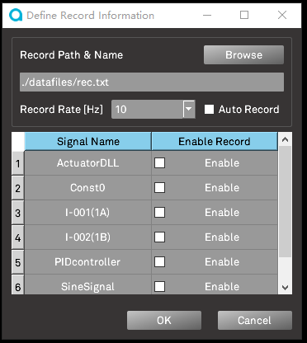

*Figure 10 – Define Record Information window*

## 4.3 Display Menu

4.3.1 Oscilloscope

By clicking “Oscilloscope”, a window as shown in Figure 11 will be opened. The window provides real-time plotting to visualize all kinds of signals. The user can choose the scope limit on “Time” and “Y-data” by using “Time Span [Sec]” and “Ymax/Ymin”, choose resolution of the plots by changing “Update Rate [Hz]”. Curve value scope will update automatically when “Auto Range” is checked. And the user can also choose which curves to plot by selecting “+Plot Data”, “-Plot Data” can cancel the selecting.

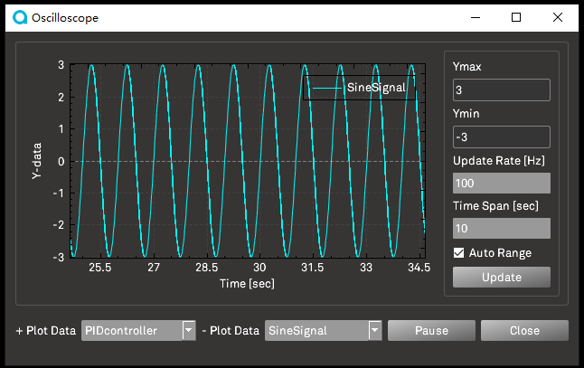

*Figure 11 – Oscilloscope window*

4.3.2 X-Y Plot

By clicking “X-Y Plot”, a window as shown in Figure 12 will be opened. The window provides real-time plotting to visualize all kinds of signals. The user can choose the “X-data” and “Y-data” by using “X Data” and “Y Data” combo boxes.

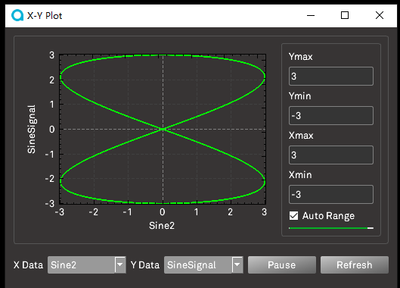

*Figure 12 – X-Y Plot window*

4.3.3 Digital Meter

By clicking “Digital Meter”, a window as shown in Figure 13 will be opened. The window provides real-time meter to visualize all kinds of signals. The user monitors the pre-defined signals value in this window via “Available Meter(s)”selection. Clicking “Open” button can reload the displaying information which was saved by “Save” button before.

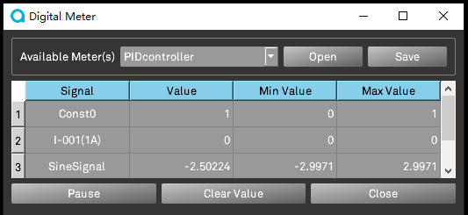

*Figure 13 – Digital Meter window*

## 4.4 Toolbox Menu

4.4.1 Workspace

By clicking “Workspace”, a window as shown in Figure 14 will be opened. The window provides all kinds of signals’ define information to visualize, such as:

* Input Signal
* Custom Signal
* Output Signal
* Sub Signal, generated by user-defined signals’ output signals
* Signal Reference, displaying dependencies between various signals

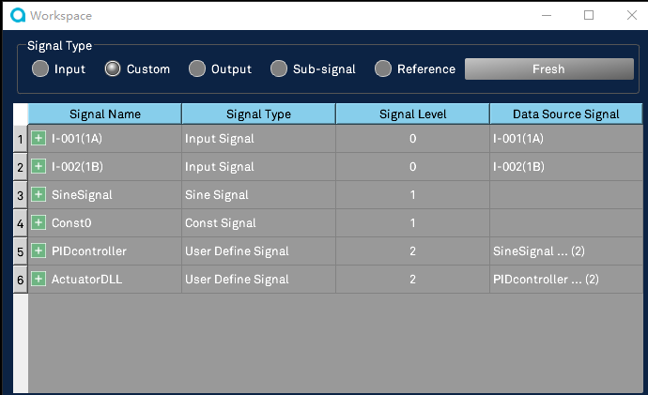

*Figure 14 – Workspace window*

4.4.2 Auto Locate

All kinds of windows will be shown at last location when “Auto Locate” menu is checked.

4.4.3 Experiment Site

ALC can performs Hybrid testing via communicating with Hardware-in-the-loop Simulation Software(HSS) by UDP network protocol.

By clicking “Experiment Site”, a window as shown in Figure 15 will be opened. The window provides Experiment Site information to define for Hardware-in-the-loop Simulation Software(HSS).

“Reference Signal” will be replaced by HSS sending reference signal.

“Feedback 1”, ALC will monitor this signal as condition of sending feedback signal to HSS. Feedback 1 signal will send back to HSS as first feedback signal.

“Feedback 2”, this signal will send back to HSS as second feedback signal.

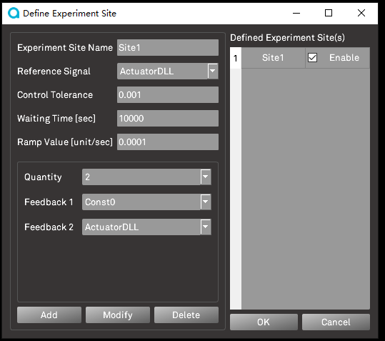

*Figure 15 – Experiment Site window*

## 4.5 Help Menu

4.5.1 User Manual

By clicking “User Manual”, a window as shown in Figure 16 will be opened. The window provides the details of this user manual.

4.5.2 Contact Information

By clicking “Contact Information”, a window as shown in Figure 17 will be opened. The window provides the details of ACTS contact information.

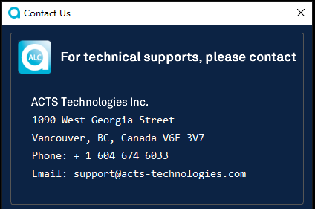

*Figure 17 – Contact Information window*

4.5.3 About

By clicking “About Information”, a window as shown in Figure 18 will be opened.

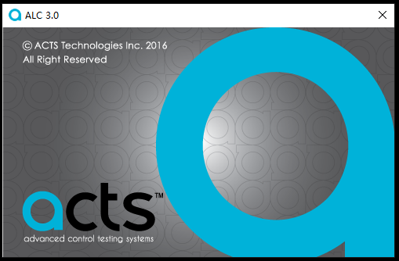

*Figure 18 – About window*

## 4.6 Main Function

There are five function-boxes in the Main Window as Figure 3 – Main window shown.

4.6.1 Control Box

By clicking “Start/Pause” and “Stop” buttons, control thread can be started, paused and stopped.

4.6.2 Alarm Box

Error and warning messages will be shown in Alarm Box. Click “Reset” button before restarts control thread when system pause or stops control thread when exceeding the limit.

4.6.3 Adjustment Box

By clicking “Signal Manage” button, a window as shown in Figure 19 will be opened. The window provides signal modifying dynamically while the control thread is running. All kinds of defined signals can be changed by types or parameters while the control thread is running.

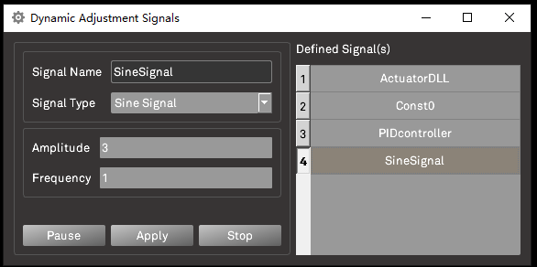

*Figure 19 – Dynamic Adjustment signals window*

“HSS Manage” button will be shown when project includes Experiment Site information setting. By clicking “HSS Manage” button, a window as shown in Figure 20 will be opened. The window provides HSS parameters setting dynamically during Hybrid testing.

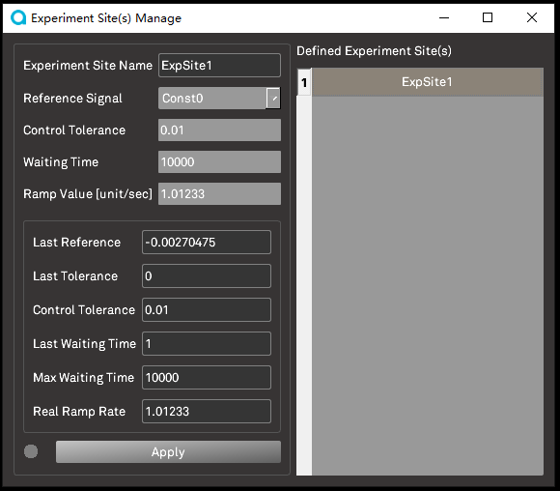

*Figure 20 - Experiment Site(s) Manage window*

4.6.4 Record Box

By clicking “Start” or “Stop” buttons, “Record thread” can be started or stopped.

4.6.5 Project Information Box

The user can select “Working Frequency [Hz]”combo box to choose the main thread frequency.

# 5. How to define a PID controller

## 5.1 Define a PID Controller Dynamic Link Library

ALC pre-defined PID controller dynamic link library (./datafiles/UserDLL/advancedSignal_PID.dll) according to the ALC Standard DLL template.

## 5.2 Define a PID Modifier

ALC pre-defined PID modifier for user as Figure-21:

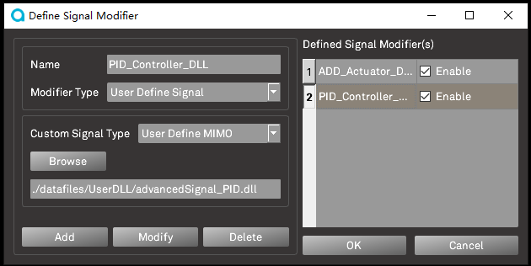

*Figure 21 - define a PID modifier window*

## 5.3 Define a PID Controller Signal

ALC pre-defined PID controller signal for user as Figure-22:

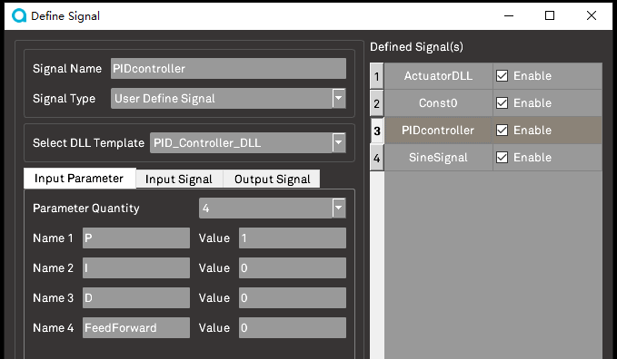

*Figure 22 - define a PID controller signal window*

If you have any questions regarding this manual, please contact ACTS.